Data Engineering with Databricks V2

<https://adb-5452879900833533.13.azuredatabricks.net>

[odl_user_783173@databrickslabs.com](mailto:odl_user_783173@databrickslabs.com)

sadw62DZR*QK

Parallel to spark engine photon is Public Preview of classic workspaces.

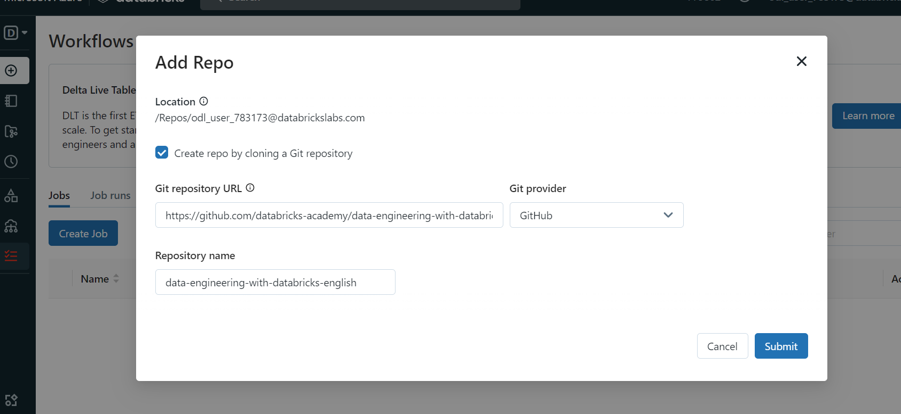

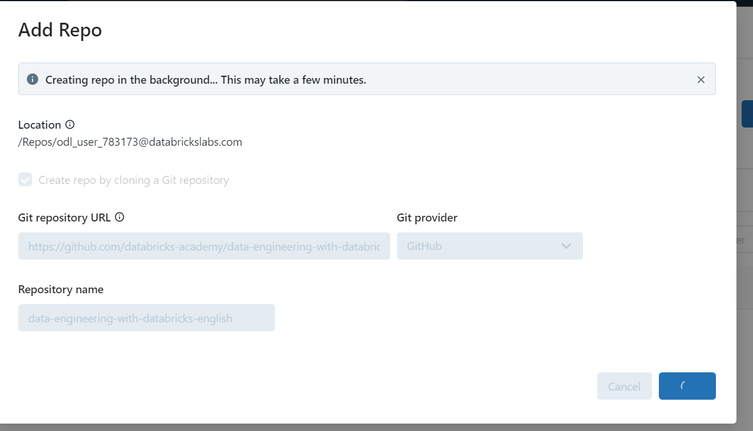

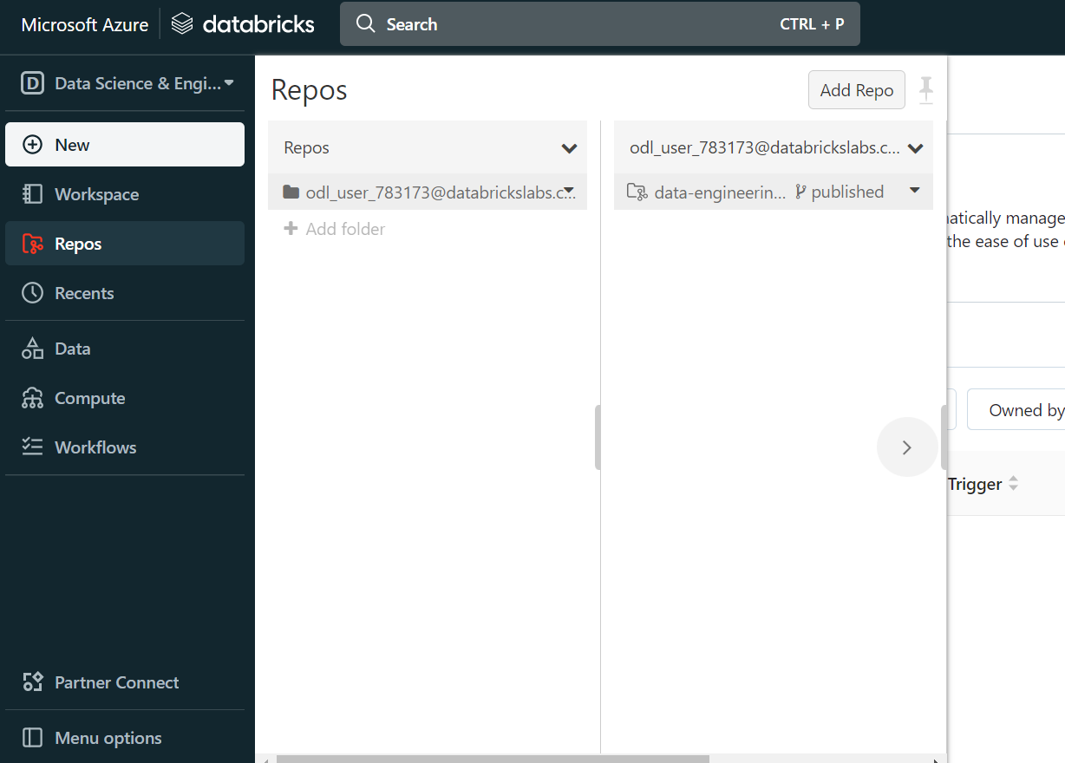

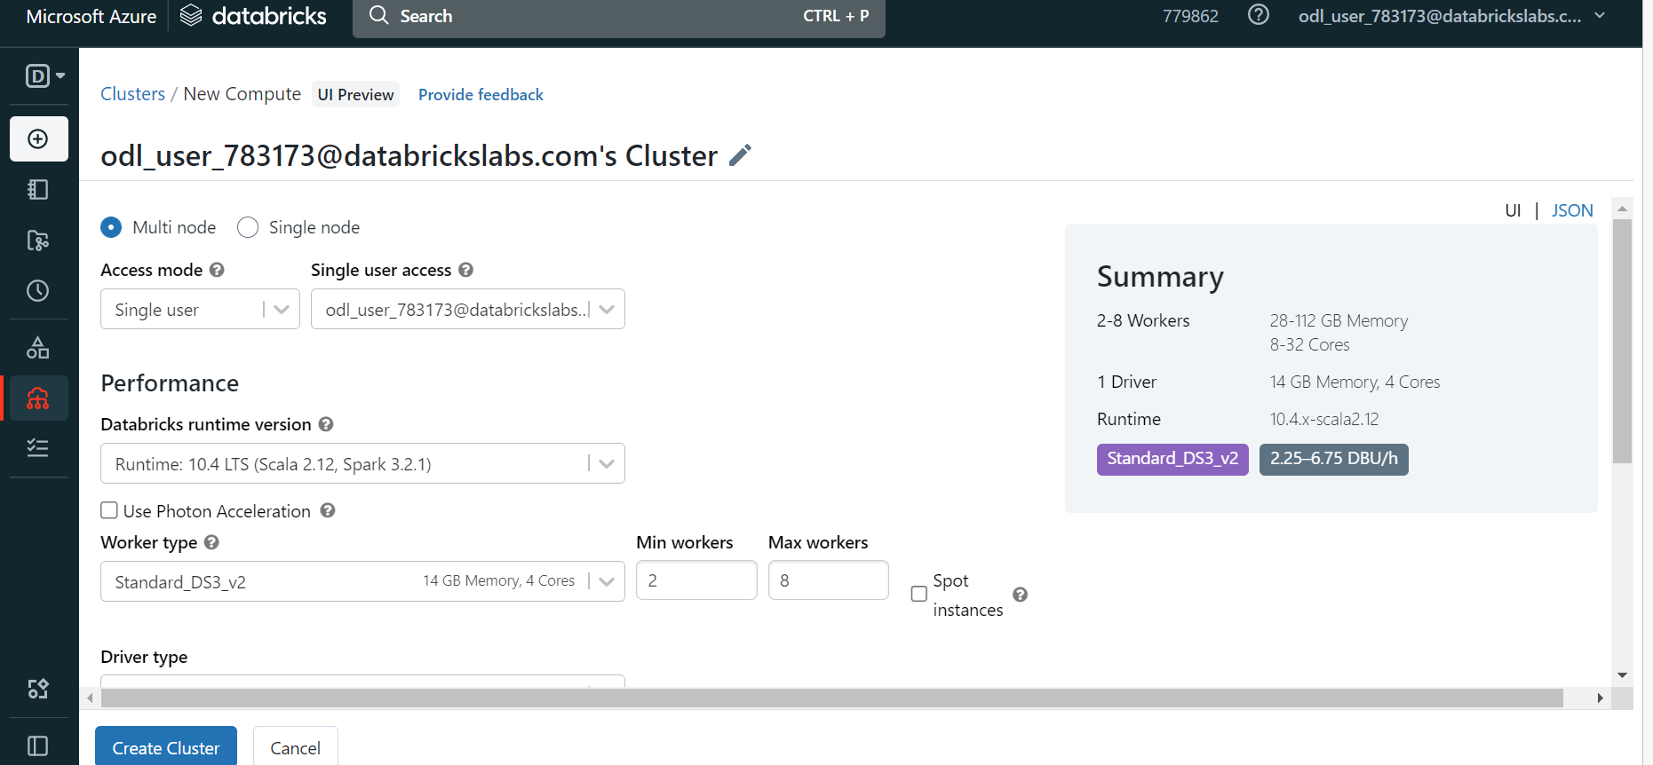

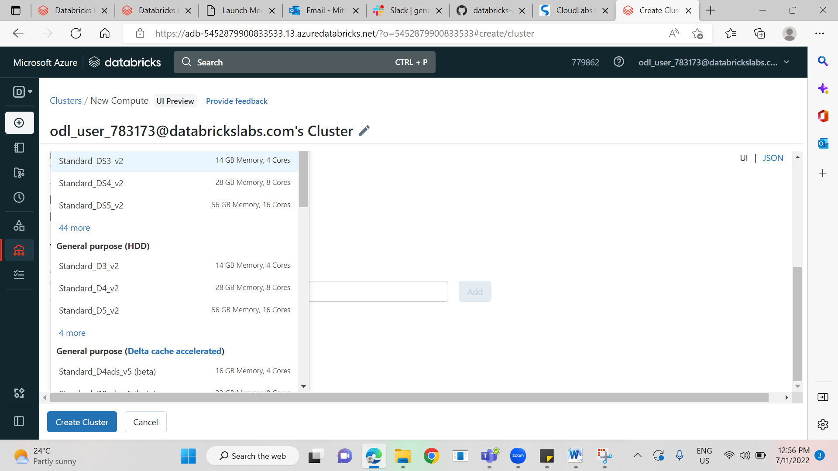

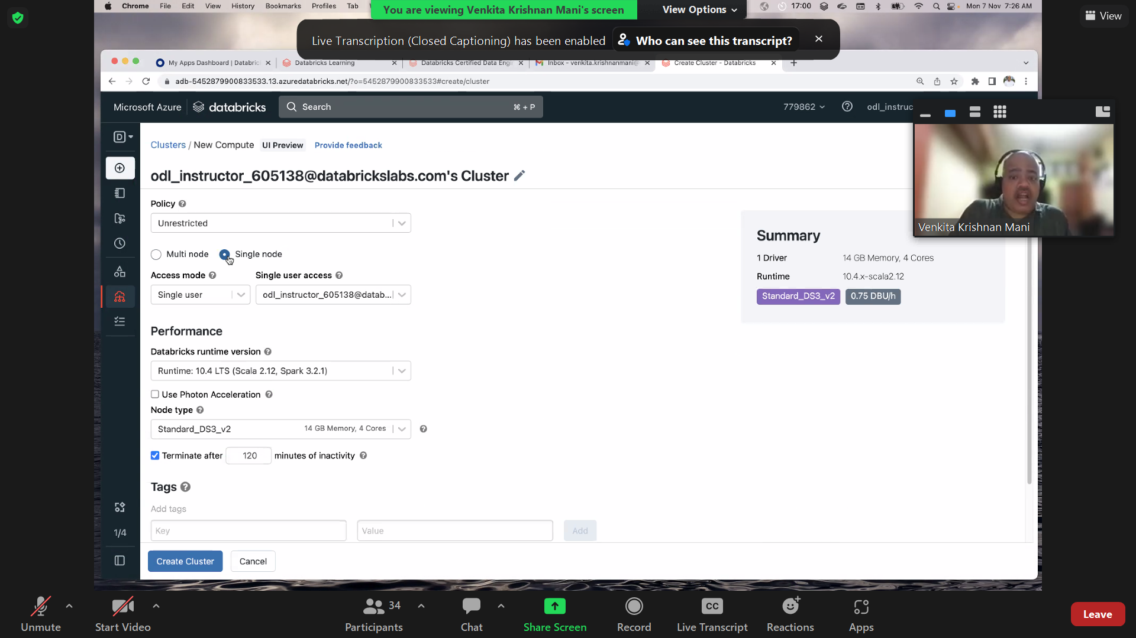

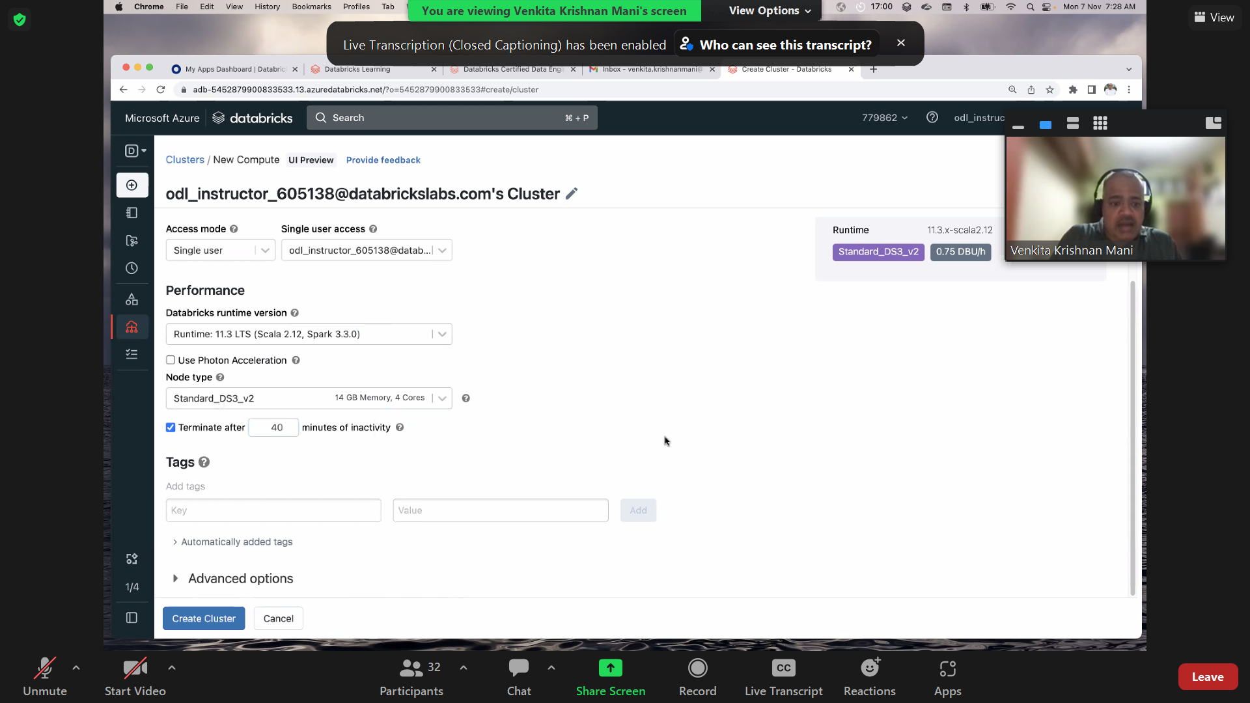

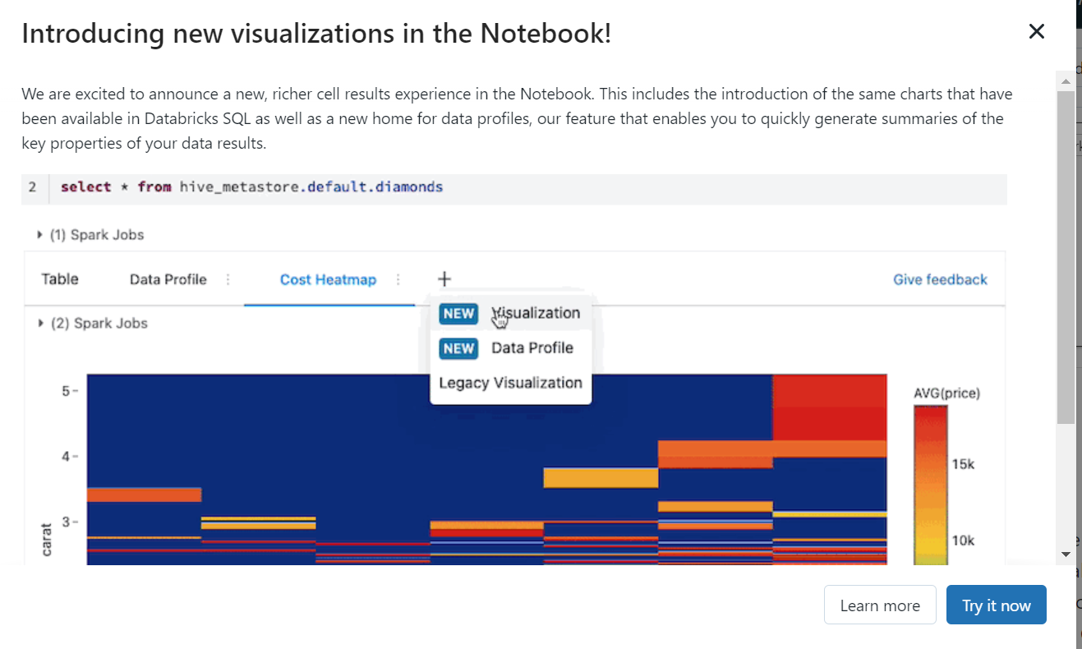

[Visualizations - Azure Databricks | Microsoft Learn](https://learn.microsoft.com/en-us/azure/databricks/notebooks/visualizations/)

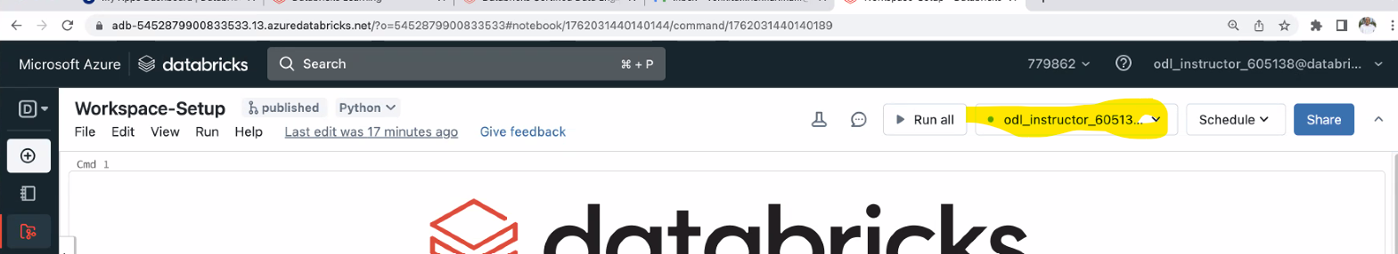

The highlighted one is to connect to the clusters in the list that is spined up.

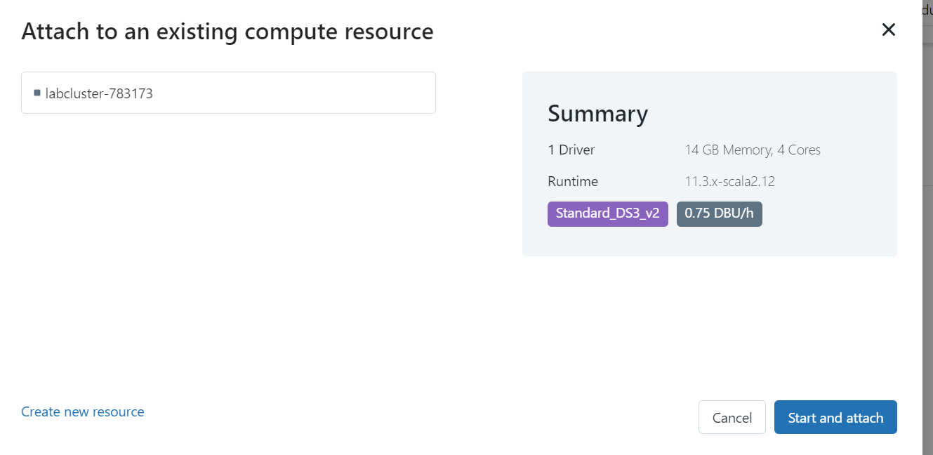

## Delta Live Tables (DLT) is generally available!

DLT is the first ETL framework that uses a simple declarative approach to build reliable data pipelines and automatically manage your infrastructure at scale. To get started, follow the [quickstart guide](https://docs.microsoft.com/azure/databricks/workflows/delta-live-tables/delta-live-tables-quickstart), watch [the demo](https://www.youtube.com/watch?v=BIxwoO65ylY), and read our [launch blog](https://databricks.com/blog/2022/04/05/announcing-generally-availability-of-databricks-delta-live-tables-dlt.html) to discover the ease of use of DLT for data engineers and analysts alike.

[Announcing General Availability of Databricks’ Delta Live Tables (DLT) - The Databricks Blog](https://www.databricks.com/blog/2022/04/05/announcing-generally-availability-of-databricks-delta-live-tables-dlt.html)

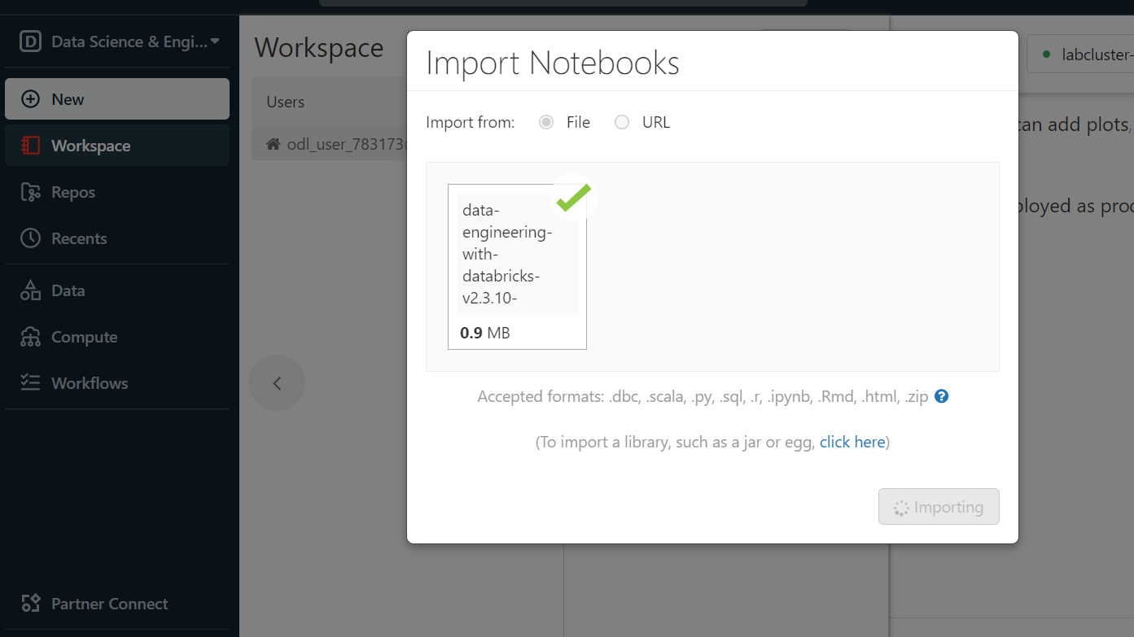

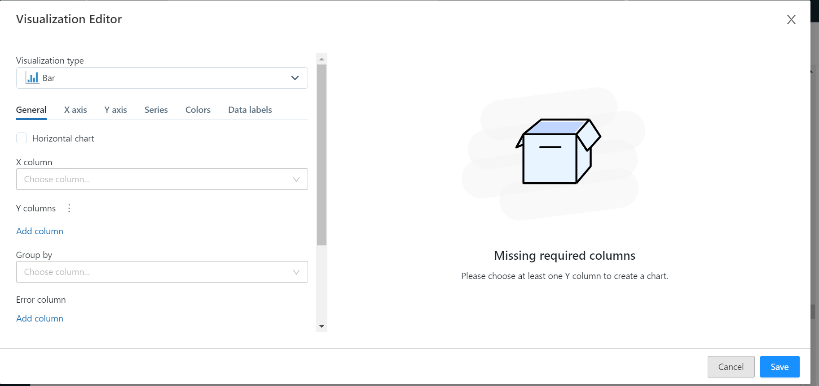

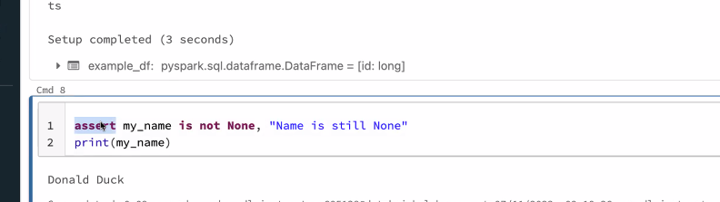

[Databricks Learning](https://partner-academy.databricks.com/learn/course/62/data-engineering-with-databricks-v2)

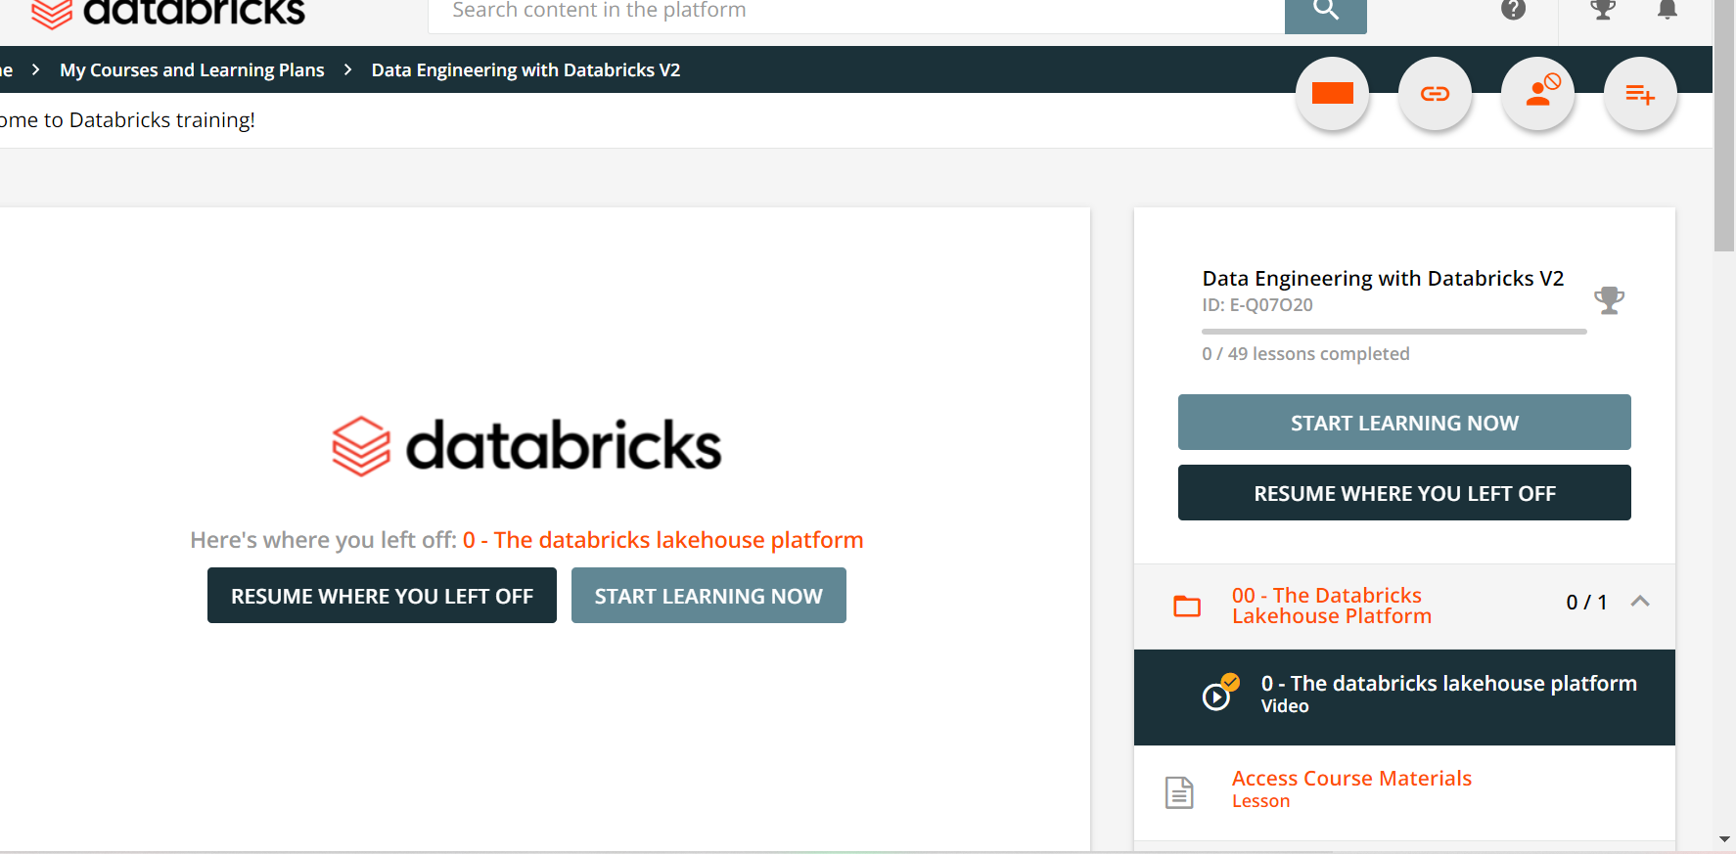

# Another course: Databricks Lakehouse Fundamentals

